**SOCY7708: Hierarchical Linear Modeling**

**Instructor: Natasha Sarkisian**

**Class notes: Interpreting Interactions in HLM**

So far, we looked at a cross-level interaction of a continuous level-1 variable, SES, and a dichotomous level 2 variable, SECTOR, but there can be various other combinations; we will discuss four:

1. Two dichotomous variables
2. A dichotomy and a continuous variable
3. A multicategory variable and a continuous variable
4. Two continuous variables

What is crucial for interpretation in all of these cases is to consider the size and significance of what’s called simple slopes – that is, the slope of X when moderator Z is at a specified value. That means, we should always consider one variable as the focal one (X) and one as the moderator (Z). It’s arbitrary for a given interaction which one is which – but it usually makes substantive sense to designate one variable as the focal one and the other as the moderator. In HLM, we typically discuss explaining variance in level 1 slopes using level 2 variables, so that would suggest that level 1 variable would serve as your focal variable, and level 2 variable serve as a moderator, but we can always invert that interpretation – for example, rather than discussing how the effect of SES is different in Catholic vs public schools (ses=focal, sector=moderator), we could discuss the size of the school type effect for students with different levels of SES – for instance, high, medium, low (sector=focal, ses=moderator). In what follows, I will discuss interpretation for each of the four possible variable combinations and show some tools for easier interpretation.

**Example 1: Two dichotomous variables**

Here, we will look at a cross-level interaction of sector on level 2 and minority on level 1:

. mixed mathach i.minority##i.sector ses size || id:minority, cov(unstr)

Mixed-effects ML regression Number of obs = 7,185

Group variable: id Number of groups = 160

Obs per group:

min = 14

avg = 44.9

max = 67

Wald chi2(5) = 879.58

Log likelihood = -23175.932 Prob > chi2 = 0.0000

---------------------------------------------------------------------------------

mathach | Coefficient Std. err. z P>|z| [95% conf. interval]

----------------+----------------------------------------------------------------

1.minority | -4.226579 .3040739 -13.90 0.000 -4.822553 -3.630605

1.sector | 2.266543 .3311193 6.85 0.000 1.617561 2.915525

|

minority#sector |

1 1 | 2.187448 .4225161 5.18 0.000 1.359331 3.015564

|

ses | 2.04651 .1056623 19.37 0.000 1.839416 2.253605

size | .0009792 .0002577 3.80 0.000 .000474 .0014844

_cons | 11.44099 .3914482 29.23 0.000 10.67376 12.20821

---------------------------------------------------------------------------------

------------------------------------------------------------------------------

Random-effects parameters | Estimate Std. err. [95% conf. interval]

-----------------------------+------------------------------------------------

id: Unstructured |

var(minority) | .5397437 .6465572 .0515865 5.647276

var(_cons) | 2.319074 .4180191 1.628858 3.301763

cov(minority,_cons) | -.0819745 .4043974 -.8745789 .7106299

-----------------------------+------------------------------------------------

var(Residual) | 35.93477 .6106514 34.75763 37.15178

------------------------------------------------------------------------------

LR test vs. linear model: chi2(3) = 205.32 Prob > chi2 = 0.0000

Note: LR test is conservative and provided only for reference.

Minority as the focal variable, sector as the moderator:

For public schools, minority students have math achievement scores that are 4.2 units lower than non-minority students. For Catholic schools, minority students have math achievement scores that are 2 units lower (-4.2+2.2=-2) than non-minority students. So the effect of being a minority is more pronounced in public than in Catholic schools, and difference in effects is statistically significant (as indicated by the significant interaction term). We know that the effect of being a minority is significant for public schools, but what about in Catholic schools? We can find out if we reverse the dummy variable (by running the same mixed command with ib1.minority) or using margins command:

. margins, dydx(minority) at(sector=(0 1)) atmeans

Conditional marginal effects Number of obs = 7,185

Expression: Linear prediction, fixed portion, predict()

dy/dx wrt: 1.minority

1._at: 0.minority = .725261 (mean)

1.minority = .274739 (mean)

sector = 0

ses = .0001434 (mean)

size = 1056.862 (mean)

2._at: 0.minority = .725261 (mean)

1.minority = .274739 (mean)

sector = 1

ses = .0001434 (mean)

size = 1056.862 (mean)

------------------------------------------------------------------------------

| Delta-method

| dy/dx std. err. z P>|z| [95% conf. interval]

-------------+----------------------------------------------------------------

0.minority | (base outcome)

-------------+----------------------------------------------------------------

1.minority |

_at |

1 | -4.226579 .3040739 -13.90 0.000 -4.822553 -3.630605

2 | -2.039132 .296945 -6.87 0.000 -2.621133 -1.45713

------------------------------------------------------------------------------

Note: dy/dx for factor levels is the discrete change from the base level.

Here, we can see that even though the effect of being a minority is smaller in Catholic schools than in public schools, it is nevertheless significant in both types of schools.

Sector as the focal variable, minority as the moderator:

Among non-minority students, those in Catholic schools have math achievement scores that are 2.3 units higher than those in public schools. And among minority students, that gap is even higher – minority students in Catholic schools have scores that are 4.5 units higher than minority students in public schools. Again, this difference in effects of school type is significant because the interaction term is significant. And margins command will help us see if simple slopes of sector are significant at both values of minority variable:

. margins, dydx(sector) at(minority=(0 1)) atmeans

Conditional marginal effects Number of obs = 7,185

Expression: Linear prediction, fixed portion, predict()

dy/dx wrt: 1.sector

1._at: minority = 0

0.sector = .5068894 (mean)

1.sector = .4931106 (mean)

ses = .0001434 (mean)

size = 1056.862 (mean)

2._at: minority = 1

0.sector = .5068894 (mean)

1.sector = .4931106 (mean)

ses = .0001434 (mean)

size = 1056.862 (mean)

------------------------------------------------------------------------------

| Delta-method

| dy/dx std. err. z P>|z| [95% conf. interval]

-------------+----------------------------------------------------------------

0.sector | (base outcome)

-------------+----------------------------------------------------------------

1.sector |

_at |

1 | 2.266543 .3311193 6.85 0.000 1.617561 2.915525

2 | 4.45399 .4630216 9.62 0.000 3.546485 5.361496

------------------------------------------------------------------------------

Note: dy/dx for factor levels is the discrete change from the base level.

Here, we can see that indeed, the effect of school type is significant for both minority and non-minority students. Finally, to further assist our interpretation, we could calculate predicted values of math achievement for the 4 groups based on minority and sector variables:

. margins, at(minority=(0 1) sector=(0 1)) atmeans

Adjusted predictions Number of obs = 7,185

Expression: Linear prediction, fixed portion, predict()

1._at: minority = 0

sector = 0

ses = .0001434 (mean)

size = 1056.862 (mean)

2._at: minority = 0

sector = 1

ses = .0001434 (mean)

size = 1056.862 (mean)

3._at: minority = 1

sector = 0

ses = .0001434 (mean)

size = 1056.862 (mean)

4._at: minority = 1

sector = 1

ses = .0001434 (mean)

size = 1056.862 (mean)

------------------------------------------------------------------------------

| Delta-method

| Margin std. err. z P>|z| [95% conf. interval]

-------------+----------------------------------------------------------------

_at |

1 | 12.47616 .213089 58.55 0.000 12.05851 12.8938

2 | 14.7427 .2364074 62.36 0.000 14.27935 15.20605

3 | 8.249577 .3181134 25.93 0.000 7.626086 8.873068

4 | 12.70357 .3115603 40.77 0.000 12.09292 13.31421

------------------------------------------------------------------------------

The scores are highest for non-minority students in Catholic schools and lowest for minority students in public schools.

**Example 2: A dichotomy and a continuous variable**

Here, we will look at a dichotomous variable minority on level 1 and a continuous variable size on level 2, but similar interpretation approaches can be used if your continuous variable is on level 1 and your dichotomy is on level 2.

. sum size

Variable | Obs Mean Std. dev. Min Max

-------------+---------------------------------------------------------

size | 7,185 1056.862 604.1725 100 2713

. egen tagged=tag(id)

. sum size if tagged==1

Variable | Obs Mean Std. dev. Min Max

-------------+---------------------------------------------------------

size | 160 1097.825 629.5064 100 2713

. gen sizem=size-r(mean)

. mixed mathach i.minority##c.sizem || id: minority, cov(unstr)

Mixed-effects ML regression Number of obs = 7,185

Group variable: id Number of groups = 160

Obs per group:

min = 14

avg = 44.9

max = 67

Wald chi2(3) = 224.93

Log likelihood = -23393.211 Prob > chi2 = 0.0000

----------------------------------------------------------------------------------

mathach | Coefficient Std. err. z P>|z| [95% conf. interval]

-----------------+----------------------------------------------------------------

1.minority | -3.723111 .2577542 -14.44 0.000 -4.2283 -3.217922

sizem | .0002325 .0003452 0.67 0.501 -.0004442 .0009092

|

minority#c.sizem |

1 | -.0015012 .0004082 -3.68 0.000 -.0023012 -.0007012

|

_cons | 13.69733 .209928 65.25 0.000 13.28588 14.10878

----------------------------------------------------------------------------------

------------------------------------------------------------------------------

Random-effects parameters | Estimate Std. err. [95% conf. interval]

-----------------------------+------------------------------------------------

id: Unstructured |

var(minority) | 2.262594 .9714639 .9752954 5.249008

var(_cons) | 5.561104 .78949 4.210357 7.34519

cov(minority,_cons) | .9227327 .6520362 -.3552349 2.2007

-----------------------------+------------------------------------------------

var(Residual) | 37.41324 .6361601 36.18693 38.6811

------------------------------------------------------------------------------

LR test vs. linear model: chi2(3) = 741.52 Prob > chi2 = 0.0000

Note: LR test is conservative and provided only for reference.

Minority as the focal variable, size as the moderator:

In schools of average (mean) size, minority students have math achievement scores that are 3.7 units lower than non-minority students. If school size is one SD (629.5) higher than average, minority students have math achievement scores that are 4.6 units lower than non-minority students (calculated as -3.7-.0015012*629.5).

. di -3.7 -.0015012*629.5

-4.6450054

If school size is one SD lower than average, minority students have math achievement scores that are 2.8 units lower than non-minority students.

. di -3.7 +.0015012*629.5

-2.7549946

So we conclude that the race/ethnicity gap in more pronounced in larger schools than in smaller schools, and that difference is statistically significant (as indicated by the significant interaction term). To see if simple slopes of minority are significant at various levels of size variable, we employ margins command:

. sum sizem if tagged==1

Variable | Obs Mean Std. dev. Min Max

-------------+---------------------------------------------------------

sizem | 160 -3.86e-06 629.5064 -997.825 1615.175

. return list

scalars:

r(N) = 160

r(sum_w) = 160

r(mean) = -3.86238098145e-06

r(Var) = 396278.3592549189

r(sd) = 629.5064409955778

r(min) = -997.8250122070313

r(max) = 1615.175048828125

r(sum) = -.0006179809570313

. global min=r(min)

. global max=r(max)

. global mean=r(mean)

. global plussd=r(mean)+r(sd)

. global minussd=r(mean)-r(sd)

. margins, dydx(minority) at(size=($min $minussd $mean $plussd $max)) atmeans

Conditional marginal effects Number of obs = 7,185

Expression: Linear prediction, fixed portion, predict()

dy/dx wrt: 1.minority

1._at: 0.minority = .725261 (mean)

1.minority = .274739 (mean)

sizem = -997.825

2._at: 0.minority = .725261 (mean)

1.minority = .274739 (mean)

sizem = -629.5064

3._at: 0.minority = .725261 (mean)

1.minority = .274739 (mean)

sizem = -3.86e-06

4._at: 0.minority = .725261 (mean)

1.minority = .274739 (mean)

sizem = 629.5064

5._at: 0.minority = .725261 (mean)

1.minority = .274739 (mean)

sizem = 1615.175

------------------------------------------------------------------------------

| Delta-method

| dy/dx std. err. z P>|z| [95% conf. interval]

-------------+----------------------------------------------------------------

0.minority | (base outcome)

-------------+----------------------------------------------------------------

1.minority |

_at |

1 | -2.225132 .4869101 -4.57 0.000 -3.179458 -1.270805

2 | -2.778068 .3680558 -7.55 0.000 -3.499444 -2.056692

3 | -3.723111 .2577542 -14.44 0.000 -4.2283 -3.217922

4 | -4.668154 .359792 -12.97 0.000 -5.373333 -3.962974

5 | -6.147883 .7023876 -8.75 0.000 -7.524537 -4.771229

------------------------------------------------------------------------------

Note: dy/dx for factor levels is the discrete change from the base level.

Size as the focal variable, minority as the moderator:

For non-minority students, if a school has one extra student (school size increases by 1), then their math achievement increases by .0002 of a unit, but that increase is not statistically significant. For minority students, if the school size increases by 1, their math achievement decreases by .001 of a unit:

. di .0002325-.0015012

-.0012687

But we don’t know yet if that’s a significant decrease – we need to use margins to look at that simple slope:

. margins, dydx(sizem) at(minority=(0 1)) atmeans

Conditional marginal effects Number of obs = 7,185

Expression: Linear prediction, fixed portion, predict()

dy/dx wrt: sizem

1._at: minority = 0

sizem = -40.96321 (mean)

2._at: minority = 1

sizem = -40.96321 (mean)

------------------------------------------------------------------------------

| Delta-method

| dy/dx std. err. z P>|z| [95% conf. interval]

-------------+----------------------------------------------------------------

sizem |

_at |

1 | .0002325 .0003452 0.67 0.501 -.0004442 .0009092

2 | -.0012687 .0004836 -2.62 0.009 -.0022166 -.0003209

------------------------------------------------------------------------------

Here, we can see that the effect of school size is statistically significant for minority students but not for the non-minority students. The size of coefficient for minority students still looks small, but that’s because one unit for school size is small – it’s one student. Let’s look how much change that would be for one SD increase in school size:

. di -.0012687*629.5

-.79864665

We can also show these slopes on a graph, but to have a better scale, we will reestimate the model with size being uncentered (the results don’t substantively change from that although the constant and main effects coefficients are less interpretable, but the graph is exactly the same, just labeled better):

. mixed mathach i.minority##c.size || id: minority, cov(unstr)

Mixed-effects ML regression Number of obs = 7,185

Group variable: id Number of groups = 160

Obs per group:

min = 14

avg = 44.9

max = 67

Wald chi2(3) = 224.93

Log likelihood = -23393.211 Prob > chi2 = 0.0000

---------------------------------------------------------------------------------

mathach | Coefficient Std. err. z P>|z| [95% conf. interval]

----------------+----------------------------------------------------------------

1.minority | -2.075007 .5219894 -3.98 0.000 -3.098088 -1.051927

size | .0002325 .0003452 0.67 0.501 -.0004442 .0009092

|

minority#c.size |

1 | -.0015012 .0004082 -3.68 0.000 -.0023012 -.0007012

|

_cons | 13.44209 .4274142 31.45 0.000 12.60437 14.2798

---------------------------------------------------------------------------------

------------------------------------------------------------------------------

Random-effects parameters | Estimate Std. err. [95% conf. interval]

-----------------------------+------------------------------------------------

id: Unstructured |

var(minority) | 2.262594 .9714639 .9752954 5.249008

var(_cons) | 5.561104 .78949 4.210357 7.34519

cov(minority,_cons) | .9227327 .6520362 -.3552349 2.2007

-----------------------------+------------------------------------------------

var(Residual) | 37.41324 .6361601 36.18693 38.6811

------------------------------------------------------------------------------

LR test vs. linear model: chi2(3) = 741.52 Prob > chi2 = 0.0000

Note: LR test is conservative and provided only for reference.

. sum size if tagged==1

Variable | Obs Mean Std. dev. Min Max

-------------+---------------------------------------------------------

size | 160 1097.825 629.5064 100 2713

. global min=r(min)

. global max=r(max)

. global mean=r(mean)

. global plussd=r(mean)+r(sd)

. global minussd=r(mean)-r(sd)

. margins, at(minority=(0 1) size=($min $minussd $mean $plussd $max))

Adjusted predictions Number of obs = 7,185

Expression: Linear prediction, fixed portion, predict()

1._at: minority = 0

size = 100

2._at: minority = 0

size = 468.3186

3._at: minority = 0

size = 1097.825

4._at: minority = 0

size = 1727.331

5._at: minority = 0

size = 2713

6._at: minority = 1

size = 100

7._at: minority = 1

size = 468.3186

8._at: minority = 1

size = 1097.825

9._at: minority = 1

size = 1727.331

10._at: minority = 1

size = 2713

------------------------------------------------------------------------------

| Delta-method

| Margin std. err. z P>|z| [95% conf. interval]

-------------+----------------------------------------------------------------

_at |

1 | 13.46534 .3976975 33.86 0.000 12.68586 14.24481

2 | 13.55097 .297343 45.57 0.000 12.96819 14.13375

3 | 13.69733 .209928 65.25 0.000 13.28588 14.10878

4 | 13.84368 .3069108 45.11 0.000 13.24215 14.44522

5 | 14.07285 .6020278 23.38 0.000 12.89289 15.2528

6 | 11.2402 .5838319 19.25 0.000 10.09592 12.38449

7 | 10.7729 .4436979 24.28 0.000 9.903269 11.64253

8 | 9.974216 .3125363 31.91 0.000 9.361656 10.58678

9 | 9.17553 .4287868 21.40 0.000 8.335124 10.01594

10 | 7.924965 .8313537 9.53 0.000 6.295541 9.554388

------------------------------------------------------------------------------

. marginsplot, x(size)

Variables that uniquely identify margins: minority size

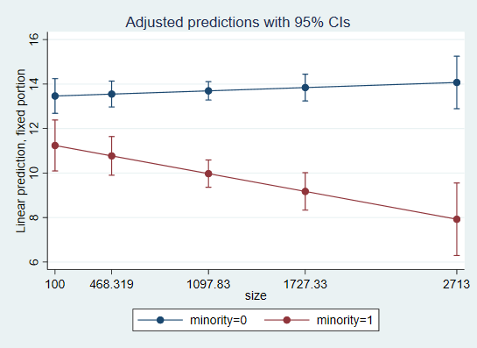

. marginsplot, x(size) plotop(msymbol(i)) recastci(rarea) ciopts(fintensity(5)) scheme(s1mono)

Variables that uniquely identify margins: minority size

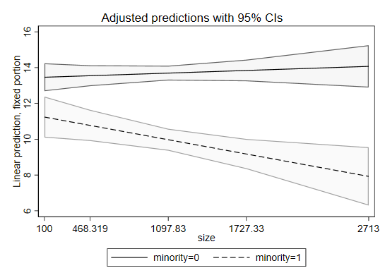

We can also graph the size of minority gap at different levels of school size – this graph would be used to assist interpretation when minority is the focal variable and school size is the moderator:

. margins, dydx(minority) at(size=($min $minussd $mean $plussd $max)) atmeans

Conditional marginal effects Number of obs = 7,185

Expression: Linear prediction, fixed portion, predict()

dy/dx wrt: 1.minority

1._at: 0.minority = .725261 (mean)

1.minority = .274739 (mean)

size = 100

2._at: 0.minority = .725261 (mean)

1.minority = .274739 (mean)

size = 468.3186

3._at: 0.minority = .725261 (mean)

1.minority = .274739 (mean)

size = 1097.825

4._at: 0.minority = .725261 (mean)

1.minority = .274739 (mean)

size = 1727.331

5._at: 0.minority = .725261 (mean)

1.minority = .274739 (mean)

size = 2713

------------------------------------------------------------------------------

| Delta-method

| dy/dx std. err. z P>|z| [95% conf. interval]

-------------+----------------------------------------------------------------

0.minority | (base outcome)

-------------+----------------------------------------------------------------

1.minority |

_at |

1 | -2.225132 .4869101 -4.57 0.000 -3.179458 -1.270805

2 | -2.778068 .3680557 -7.55 0.000 -3.499444 -2.056692

3 | -3.723111 .2577542 -14.44 0.000 -4.2283 -3.217922

4 | -4.668154 .359792 -12.97 0.000 -5.373333 -3.962974

5 | -6.147883 .7023876 -8.75 0.000 -7.524537 -4.771229

------------------------------------------------------------------------------

Note: dy/dx for factor levels is the discrete change from the base level.

. marginsplot

Variables that uniquely identify margins: size

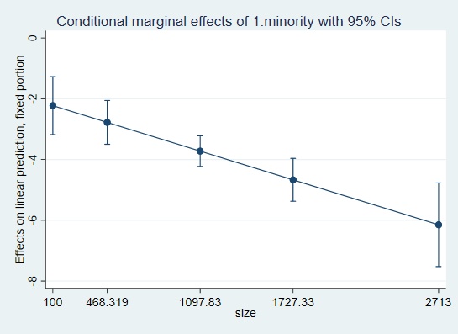

. marginsplot, plotop(msymbol(i)) recastci(rarea) ciopts(fintensity(5)) scheme(s1mono)

Variables that uniquely identify margins: size

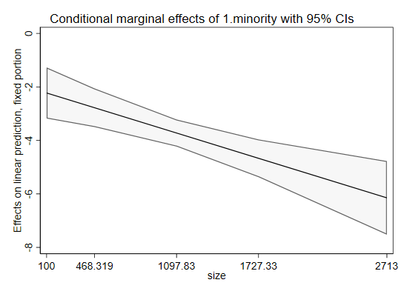

**Example 3: A multicategory variable and a continuous variable**

For this example, I will again create dummy variables for school size but this time, I’ll create four of them, approximately based on quartiles. I will use a function of egen variable to create that. My level 1 continuous variable will be SES.

. egen sized=cut(size), group(4)

. tab sized

sized | Freq. Percent Cum.

------------+-----------------------------------

0 | 1,796 25.00 25.00

1 | 1,764 24.55 49.55

2 | 1,803 25.09 74.64

3 | 1,822 25.36 100.00

------------+-----------------------------------

Total | 7,185 100.00

. mixed mathach c.ses##i.sized || id:ses, cov(unstr)

Mixed-effects ML regression Number of obs = 7,185

Group variable: id Number of groups = 160

Obs per group:

min = 14

avg = 44.9

max = 67

Wald chi2(7) = 457.54

Log likelihood = -23308.899 Prob > chi2 = 0.0000

------------------------------------------------------------------------------

mathach | Coefficient Std. err. z P>|z| [95% conf. interval]

-------------+----------------------------------------------------------------

ses | 2.100147 .2363191 8.89 0.000 1.63697 2.563324

|

sized |

1 | 1.065607 .5351867 1.99 0.046 .01666 2.114553

2 | .9430464 .5394171 1.75 0.080 -.1141917 2.000284

3 | -.2007692 .5149239 -0.39 0.697 -1.210001 .8084631

|

sized#c.ses |

1 | -.0825774 .3329181 -0.25 0.804 -.735085 .5699301

2 | .3169989 .3335864 0.95 0.342 -.3368185 .9708163

3 | .8111932 .3194897 2.54 0.011 .185005 1.437381

|

_cons | 12.25458 .3819801 32.08 0.000 11.50592 13.00325

------------------------------------------------------------------------------

------------------------------------------------------------------------------

Random-effects parameters | Estimate Std. err. [95% conf. interval]

-----------------------------+------------------------------------------------

id: Unstructured |

var(ses) | .3036592 .218077 .0743163 1.240762

var(_cons) | 4.534295 .635098 3.445767 5.966693

cov(ses,_cons) | -.0604166 .2803227 -.6098389 .4890058

-----------------------------+------------------------------------------------

var(Residual) | 36.80666 .6285147 35.59518 38.05937

------------------------------------------------------------------------------

LR test vs. linear model: chi2(3) = 428.23 Prob > chi2 = 0.0000

Note: LR test is conservative and provided only for reference.

First, I will test if the interaction terms between SES and SIZE dummies are jointly significant – you cannot judge their significance by individual coefficient significance tests because those will change depending on the omitted category.

. mat list e(b)

e(b)[1,14]

mathach: mathach: mathach: mathach: mathach: mathach: mathach:

0b. 1. 2. 3. 0b.sized# 1.sized#

ses sized sized sized sized co.ses c.ses

y1 2.1001473 0 1.0656066 .94304639 -.20076917 0 -.08257741

mathach: mathach: mathach: lns1_1_1: lns1_1_2: atr1_1_1_2: lnsig_e:

2.sized# 3.sized#

c.ses c.ses _cons _cons _cons _cons _cons

y1 .31699893 .81119323 12.254582 -.59592467 .75583481 -.05153382 1.8028394

. test 1.sized#c.ses=0

( 1) [mathach]1.sized#c.ses = 0

chi2( 1) = 0.06

Prob > chi2 = 0.8041

. test 2.sized#c.ses=0, acc

( 1) [mathach]1.sized#c.ses = 0

( 2) [mathach]2.sized#c.ses = 0

chi2( 2) = 1.61

Prob > chi2 = 0.4475

. test 3.sized#c.ses=0, acc

( 1) [mathach]1.sized#c.ses = 0

( 2) [mathach]2.sized#c.ses = 0

( 3) [mathach]3.sized#c.ses = 0

chi2( 3) = 9.92

Prob > chi2 = 0.0193

They are jointly significant. And in fact, if we wanted to better highlight that with significant coefficients when presenting the results, we may want to omit the last rather than the first SIZE category (so compare everything to the largest schools):

. mixed mathach c.ses##ib3.sized || id:ses, cov(unstr)

Computing standard errors ...

Mixed-effects ML regression Number of obs = 7,185

Group variable: id Number of groups = 160

Obs per group:

min = 14

avg = 44.9

max = 67

Wald chi2(7) = 457.54

Log likelihood = -23308.899 Prob > chi2 = 0.0000

------------------------------------------------------------------------------

mathach | Coefficient Std. err. z P>|z| [95% conf. interval]

-------------+----------------------------------------------------------------

ses | 2.911341 .2150045 13.54 0.000 2.489939 3.332742

|

sized |

0 | .2007692 .5149239 0.39 0.697 -.8084631 1.210001

1 | 1.266376 .5096605 2.48 0.013 .2674596 2.265292

2 | 1.143816 .514101 2.22 0.026 .1361962 2.151435

|

sized#c.ses |

0 | -.8111932 .3194897 -2.54 0.011 -1.437381 -.185005

1 | -.8937706 .3181426 -2.81 0.005 -1.517319 -.2702227

2 | -.4941943 .3188418 -1.55 0.121 -1.119113 .1307242

|

_cons | 12.05381 .3453083 34.91 0.000 11.37702 12.73061

------------------------------------------------------------------------------

------------------------------------------------------------------------------

Random-effects parameters | Estimate Std. err. [95% conf. interval]

-----------------------------+------------------------------------------------

id: Unstructured |

var(ses) | .3036591 .2180771 .0743163 1.240763

var(_cons) | 4.534295 .635098 3.445767 5.966693

cov(ses,_cons) | -.0604166 .2803227 -.6098389 .4890057

-----------------------------+------------------------------------------------

var(Residual) | 36.80666 .6285147 35.59518 38.05937

------------------------------------------------------------------------------

LR test vs. linear model: chi2(3) = 428.23 Prob > chi2 = 0.0000

Note: LR test is conservative and provided only for reference.

SES as the focal variable, SIZE dummies as a moderator:

First, let’s focus on level 1 variable – SES – as our focal one. The main effect for SES shows that for largest schools, 1 unit increase in SES translates into 2.9 units increase in math achievement. For the next largest size of schools, that effect would be 2.9-.5=2.4. Instead of calculating that manually, I will use margins again:

. margins, dydx(ses) at(sized=(0 1 2 3)) atmeans

Conditional marginal effects Number of obs = 7,185

Expression: Linear prediction, fixed portion, predict()

dy/dx wrt: ses

1._at: ses = .0001434 (mean)

sized = 0

2._at: ses = .0001434 (mean)

sized = 1

3._at: ses = .0001434 (mean)

sized = 2

4._at: ses = .0001434 (mean)

sized = 3

------------------------------------------------------------------------------

| Delta-method

| dy/dx std. err. z P>|z| [95% conf. interval]

-------------+----------------------------------------------------------------

ses |

_at |

1 | 2.100147 .2363191 8.89 0.000 1.63697 2.563324

2 | 2.01757 .2344947 8.60 0.000 1.557969 2.477171

3 | 2.417146 .2354425 10.27 0.000 1.955687 2.878605

4 | 2.911341 .2150045 13.54 0.000 2.489939 3.332742

------------------------------------------------------------------------------

The effect of SES is significant for all school sizes but it’s more pronounced in the largest schools (the largest schools are significantly different from the smallest and second smallest, but not from the second largest category with regard to the size of SES effect on math achievement).

I may also want to estimate and present this model with an alternative parametrization that allows me to right away see SES slopes separately for each size category; this model doesn’t include the interaction terms so we couldn’t see if SES slopes are different depending on SIZE, so it should only be used as a follow-up to a standard model with interactions if we find that they are significant. This parametrization is called the separate slope parameterization, it includes four separate SES coefficients for the four SIZE groups rather than the more conventional interaction term parameterization (main effect of SES and three interaction terms for SIZE). For that, we create four variables in which one size-based group’s SES values are included along with zeroes for the other three groups. These variables allow us to obtain separate simple slopes for SES for each size group. For more details on that approach, or to justify using it, see: Cohen, Jacob, Patricia Cohen, Stephen G. West, and Leona Aiken. 2003. Applied Multiple Regression/Correlation Analysis for the Behavioral Sciences, 3rd ed. Mahwah, NJ: Lawrence Erlbaum.

. tab sized, gen(sized_)

sized | Freq. Percent Cum.

------------+-----------------------------------

0 | 1,796 25.00 25.00

1 | 1,764 24.55 49.55

2 | 1,803 25.09 74.64

3 | 1,822 25.36 100.00

------------+-----------------------------------

Total | 7,185 100.00

. for num 1/4: gen ses_sized_X=ses*sized_X

-> gen ses_sized_1=ses*sized_1

-> gen ses_sized_2=ses*sized_2

-> gen ses_sized_3=ses*sized_3

-> gen ses_sized_4=ses*sized_4

. mixed mathach i.sized ses_sized* || id:ses, cov(unstr)

Mixed-effects ML regression Number of obs = 7,185

Group variable: id Number of groups = 160

Obs per group:

min = 14

avg = 44.9

max = 67

Wald chi2(7) = 457.54

Log likelihood = -23308.899 Prob > chi2 = 0.0000

------------------------------------------------------------------------------

mathach | Coefficient Std. err. z P>|z| [95% conf. interval]

-------------+----------------------------------------------------------------

sized |

1 | 1.065607 .5351867 1.99 0.046 .01666 2.114553

2 | .9430464 .5394171 1.75 0.080 -.1141917 2.000284

3 | -.2007692 .5149239 -0.39 0.697 -1.210001 .8084631

|

ses_sized_1 | 2.100147 .2363191 8.89 0.000 1.63697 2.563324

ses_sized_2 | 2.01757 .2344947 8.60 0.000 1.557969 2.477171

ses_sized_3 | 2.417146 .2354425 10.27 0.000 1.955687 2.878605

ses_sized_4 | 2.911341 .2150045 13.54 0.000 2.489939 3.332742

_cons | 12.25458 .3819801 32.08 0.000 11.50592 13.00325

------------------------------------------------------------------------------

------------------------------------------------------------------------------

Random-effects parameters | Estimate Std. err. [95% conf. interval]

-----------------------------+------------------------------------------------

id: Unstructured |

var(ses) | .3036591 .2180771 .0743162 1.240763

var(_cons) | 4.534295 .635098 3.445767 5.966693

cov(ses,_cons) | -.0604166 .2803227 -.6098389 .4890057

-----------------------------+------------------------------------------------

var(Residual) | 36.80666 .6285147 35.59518 38.05937

------------------------------------------------------------------------------

LR test vs. linear model: chi2(3) = 428.23 Prob > chi2 = 0.0000

Note: LR test is conservative and provided only for reference.

I omitted the smallest school category, but perhaps omitting the largest could be better; that doesn’t affect the simple slopes for SES that we can see in this model, however.

Next, we turn to graphic representation of our interactions results. Since my SIZED variable is ordinal, I could consider a graph illustrating the size of SES effect for each SIZE category:

. marginsplot

Variables that uniquely identify margins: sized

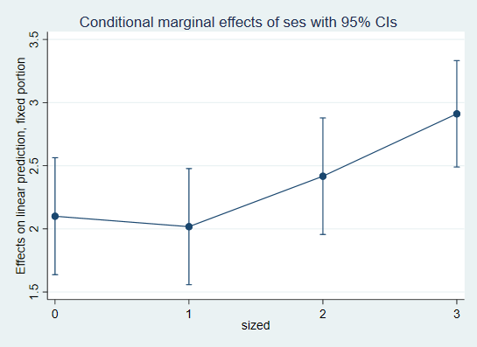

We could also illustrate this with a graph showing actual slopes of SES at each level of SIZE – for that, we do margins without dydx to generate predicted values:

. sum ses

Variable | Obs Mean Std. dev. Min Max

-------------+---------------------------------------------------------

ses | 7,185 .0001434 .7793552 -3.758 2.692

. global min=r(min)

. global max=r(max)

. global mean=r(mean)

. global plussd=r(mean)+r(sd)

. global minussd=r(mean)-r(sd)

. margins, at(sized=(0 1 2 3) ses=($min $minussd $mean $plussd $max)) atmeans

Adjusted predictions Number of obs = 7,185

Expression: Linear prediction, fixed portion, predict()

1._at: ses = -3.758

sized = 0

2._at: ses = -3.758

sized = 1

3._at: ses = -3.758

sized = 2

4._at: ses = -3.758

sized = 3

5._at: ses = -.7792118

sized = 0

6._at: ses = -.7792118

sized = 1

7._at: ses = -.7792118

sized = 2

8._at: ses = -.7792118

sized = 3

9._at: ses = .0001434

sized = 0

10._at: ses = .0001434

sized = 1

11._at: ses = .0001434

sized = 2

12._at: ses = .0001434

sized = 3

13._at: ses = .7794985

sized = 0

14._at: ses = .7794985

sized = 1

15._at: ses = .7794985

sized = 2

16._at: ses = .7794985

sized = 3

17._at: ses = 2.692

sized = 0

18._at: ses = 2.692

sized = 1

19._at: ses = 2.692

sized = 2

20._at: ses = 2.692

sized = 3

------------------------------------------------------------------------------

| Delta-method

| Margin std. err. z P>|z| [95% conf. interval]

-------------+----------------------------------------------------------------

_at |

1 | 4.362229 .9643754 4.52 0.000 2.472088 6.25237

2 | 5.738162 .984626 5.83 0.000 3.80833 7.667993

3 | 4.113994 .97967 4.20 0.000 2.193876 6.034112

4 | 1.112996 .8670579 1.28 0.199 -.5864064 2.812398

5 | 10.61812 .4229256 25.11 0.000 9.789204 11.44704

6 | 11.74807 .4298475 27.33 0.000 10.90559 12.59056

7 | 11.31416 .4304879 26.28 0.000 10.47042 12.1579

8 | 9.785262 .3782832 25.87 0.000 9.043841 10.52668

9 | 12.25488 .3819804 32.08 0.000 11.50622 13.00355

10 | 13.32048 .3748519 35.54 0.000 12.58578 14.05517

11 | 13.19798 .3808684 34.65 0.000 12.45149 13.94446

12 | 12.05423 .3453094 34.91 0.000 11.37744 12.73102

13 | 13.89164 .4251986 32.67 0.000 13.05827 14.72502

14 | 14.89288 .403804 36.88 0.000 14.10144 15.68432

15 | 15.08179 .4148992 36.35 0.000 14.2686 15.89498

16 | 14.3232 .389275 36.79 0.000 13.56023 15.08616

17 | 17.90818 .7442504 24.06 0.000 16.44947 19.36688

18 | 18.75149 .7081423 26.48 0.000 17.36355 20.13942

19 | 19.70459 .7238617 27.22 0.000 18.28584 21.12333

20 | 19.89114 .6846703 29.05 0.000 18.54921 21.23307

------------------------------------------------------------------------------

. marginsplot, x(ses)

Variables that uniquely identify margins: sized ses

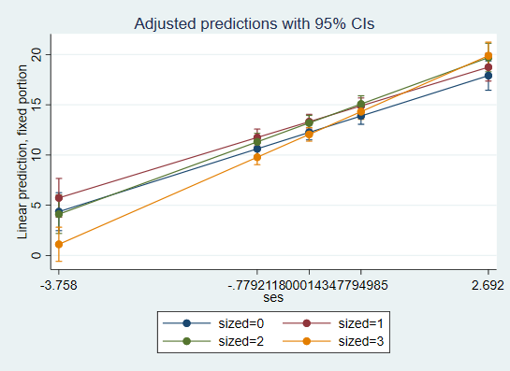

SIZE as focal, SES as a moderator:

We can use the same predicted values to create a graph focusing on SIZE as focal:

. marginsplot, x(sized)

Variables that uniquely identify margins: sized ses

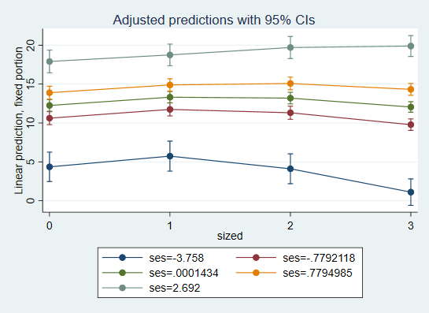

To examine which SIZE effects are statistically significant, we do margins with dydx focusing on sized:

. margins, dydx(sized) at(ses=($min $minussd $mean $plussd $max)) atmeans

Conditional marginal effects Number of obs = 7,185

Expression: Linear prediction, fixed portion, predict()

dy/dx wrt: 0.sized 1.sized 2.sized

1._at: ses = -3.758

0.sized = .2499652 (mean)

1.sized = .2455115 (mean)

2.sized = .2509395 (mean)

3.sized = .2535839 (mean)

2._at: ses = -.7792118

0.sized = .2499652 (mean)

1.sized = .2455115 (mean)

2.sized = .2509395 (mean)

3.sized = .2535839 (mean)

3._at: ses = .0001434

0.sized = .2499652 (mean)

1.sized = .2455115 (mean)

2.sized = .2509395 (mean)

3.sized = .2535839 (mean)

4._at: ses = .7794985

0.sized = .2499652 (mean)

1.sized = .2455115 (mean)

2.sized = .2509395 (mean)

3.sized = .2535839 (mean)

5._at: ses = 2.692

0.sized = .2499652 (mean)

1.sized = .2455115 (mean)

2.sized = .2509395 (mean)

3.sized = .2535839 (mean)

------------------------------------------------------------------------------

| Delta-method

| dy/dx std. err. z P>|z| [95% conf. interval]

-------------+----------------------------------------------------------------

0.sized |

_at |

1 | 3.249233 1.296846 2.51 0.012 .7074619 5.791005

2 | .8328605 .5674189 1.47 0.142 -.2792601 1.944981

3 | .2006529 .5149248 0.39 0.697 -.8085812 1.209887

4 | -.4315548 .5764797 -0.75 0.454 -1.561434 .6983247

5 | -1.982963 1.011277 -1.96 0.050 -3.96503 -.0008955

-------------+----------------------------------------------------------------

1.sized |

_at |

1 | 4.625166 1.311975 3.53 0.000 2.053742 7.196589

2 | 1.962812 .5725967 3.43 0.001 .8405435 3.085081

3 | 1.266248 .5096593 2.48 0.013 .2673338 2.265161

4 | .5696828 .5608856 1.02 0.310 -.5296327 1.668998

5 | -1.139655 .9850071 -1.16 0.247 -3.070233 .7909237

-------------+----------------------------------------------------------------

2.sized |

_at |

1 | 3.000998 1.308259 2.29 0.022 .4368563 5.565139

2 | 1.528898 .5730777 2.67 0.008 .405686 2.652109

3 | 1.143745 .5141005 2.22 0.026 .1361262 2.151363

4 | .7585918 .5689256 1.33 0.182 -.3564819 1.873665

5 | -.1865555 .996368 -0.19 0.851 -2.139401 1.76629

-------------+----------------------------------------------------------------

3.sized | (base outcome)

------------------------------------------------------------------------------

Note: dy/dx for factor levels is the discrete change from the base level.

Compared to largest schools, the smallest schools have higher math achievement scores for students with minimum SES (3.2 units higher); there are no significant differences between the largest and smallest schools at mean SES, maximum SES, or at mean+1SD and mean-1SD. The second and third category of school size are different from the largest schools in terms of math achievement for students whose SES is at mean or below (including mean itself, mean-1SD, and minimum SES). For minimum SES, the gap between the largest schools and second smallest is 4.6; the gap between the largest schools and second largest is 3 units. At mean SES, those gaps are 1.27 and 1.14, respectively. If we wanted to see those comparisons to another SIZE category, we could reestimate the model and the margins:

. mixed mathach c.ses##ib2.sized || id:ses, cov(unstr)

Performing EM optimization ...

Performing gradient-based optimization:

Iteration 0: log likelihood = -23309.269

Iteration 1: log likelihood = -23308.899

Iteration 2: log likelihood = -23308.899

Computing standard errors ...

Mixed-effects ML regression Number of obs = 7,185

Group variable: id Number of groups = 160

Obs per group:

min = 14

avg = 44.9

max = 67

Wald chi2(7) = 457.54

Log likelihood = -23308.899 Prob > chi2 = 0.0000

------------------------------------------------------------------------------

mathach | Coefficient Std. err. z P>|z| [95% conf. interval]

-------------+----------------------------------------------------------------

ses | 2.417146 .2354425 10.27 0.000 1.955687 2.878605

|

sized |

0 | -.9430464 .5394171 -1.75 0.080 -2.000284 .1141917

1 | .1225602 .534395 0.23 0.819 -.9248346 1.169955

3 | -1.143816 .514101 -2.22 0.026 -2.151435 -.1361962

|

sized#c.ses |

0 | -.3169989 .3335864 -0.95 0.342 -.9708163 .3368184

1 | -.3995763 .3322965 -1.20 0.229 -1.050865 .2517128

3 | .4941943 .3188418 1.55 0.121 -.1307242 1.119113

|

_cons | 13.19763 .38087 34.65 0.000 12.45114 13.94412

------------------------------------------------------------------------------

------------------------------------------------------------------------------

Random-effects parameters | Estimate Std. err. [95% conf. interval]

-----------------------------+------------------------------------------------

id: Unstructured |

var(ses) | .3036591 .2180771 .0743162 1.240763

var(_cons) | 4.534295 .635098 3.445767 5.966693

cov(ses,_cons) | -.0604166 .2803227 -.6098389 .4890057

-----------------------------+------------------------------------------------

var(Residual) | 36.80666 .6285147 35.59518 38.05937

------------------------------------------------------------------------------

LR test vs. linear model: chi2(3) = 428.23 Prob > chi2 = 0.0000

Note: LR test is conservative and provided only for reference.

. margins, dydx(sized) at(ses=($min $minussd $mean $plussd $max)) atmeans

Conditional marginal effects Number of obs = 7,185

Expression: Linear prediction, fixed portion, predict()

dy/dx wrt: 0.sized 1.sized 3.sized

1._at: ses = -3.758

0.sized = .2499652 (mean)

1.sized = .2455115 (mean)

2.sized = .2509395 (mean)

3.sized = .2535839 (mean)

2._at: ses = -.7792118

0.sized = .2499652 (mean)

1.sized = .2455115 (mean)

2.sized = .2509395 (mean)

3.sized = .2535839 (mean)

3._at: ses = .0001434

0.sized = .2499652 (mean)

1.sized = .2455115 (mean)

2.sized = .2509395 (mean)

3.sized = .2535839 (mean)

4._at: ses = .7794985

0.sized = .2499652 (mean)

1.sized = .2455115 (mean)

2.sized = .2509395 (mean)

3.sized = .2535839 (mean)

5._at: ses = 2.692

0.sized = .2499652 (mean)

1.sized = .2455115 (mean)

2.sized = .2509395 (mean)

3.sized = .2535839 (mean)

------------------------------------------------------------------------------

| Delta-method

| dy/dx std. err. z P>|z| [95% conf. interval]

-------------+----------------------------------------------------------------

0.sized |

_at |

1 | .2482356 1.37469 0.18 0.857 -2.446108 2.942579

2 | -.6960371 .6034782 -1.15 0.249 -1.878833 .4867584

3 | -.9430918 .5394161 -1.75 0.080 -2.000328 .1141444

4 | -1.190147 .5940835 -2.00 0.045 -2.354529 -.0257643

5 | -1.796407 1.038212 -1.73 0.084 -3.831266 .2384509

-------------+----------------------------------------------------------------

1.sized |

_at |

1 | 1.624168 1.388971 1.17 0.242 -1.098166 4.346502

2 | .4339148 .6083492 0.71 0.476 -.7584276 1.626257

3 | .1225029 .5343919 0.23 0.819 -.924886 1.169892

4 | -.188909 .5789637 -0.33 0.744 -1.323657 .945839

5 | -.9530993 1.012641 -0.94 0.347 -2.937839 1.03164

-------------+----------------------------------------------------------------

2.sized | (base outcome)

-------------+----------------------------------------------------------------

3.sized |

_at |

1 | -3.000998 1.308259 -2.29 0.022 -5.565139 -.4368563

2 | -1.528898 .5730777 -2.67 0.008 -2.652109 -.405686

3 | -1.143745 .5141005 -2.22 0.026 -2.151363 -.1361262

4 | -.7585918 .5689256 -1.33 0.182 -1.873665 .3564819

5 | .1865555 .996368 0.19 0.851 -1.76629 2.139401

------------------------------------------------------------------------------

Note: dy/dx for factor levels is the discrete change from the base level.

**Example 4: Two continuous variables**

Here, we will examine an interaction of SES and SIZE as a continuous variable rather than a set of dummies. We may want to use mean-centered SIZE variable here (we created it above).

. mixed mathach c.ses##c.sizem || id: ses, cov(unstr)

Mixed-effects ML regression Number of obs = 7,185

Group variable: id Number of groups = 160

Obs per group:

min = 14

avg = 44.9

max = 67

Wald chi2(3) = 438.94

Log likelihood = -23314.32 Prob > chi2 = 0.0000

-------------------------------------------------------------------------------

mathach | Coefficient Std. err. z P>|z| [95% conf. interval]

--------------+----------------------------------------------------------------

ses | 2.392577 .1153567 20.74 0.000 2.166482 2.618672

sizem | -.000266 .0003041 -0.87 0.382 -.0008621 .0003301

|

c.ses#c.sizem | .0004921 .0001853 2.65 0.008 .0001288 .0008554

|

_cons | 12.67515 .1890736 67.04 0.000 12.30458 13.04573

-------------------------------------------------------------------------------

------------------------------------------------------------------------------

Random-effects parameters | Estimate Std. err. [95% conf. interval]

-----------------------------+------------------------------------------------

id: Unstructured |

var(ses) | .3168798 .221958 .0802919 1.250597

var(_cons) | 4.788075 .6640414 3.64847 6.283637

cov(ses,_cons) | -.1128863 .2887151 -.6787576 .4529849

-----------------------------+------------------------------------------------

var(Residual) | 36.82078 .628957 35.60845 38.07438

------------------------------------------------------------------------------

LR test vs. linear model: chi2(3) = 461.36 Prob > chi2 = 0.0000

Note: LR test is conservative and provided only for reference.

SES as the focal variable, SIZE as the moderator:

The main effect of SES shows that at average school size, SES has a positive effect on math achievement – in average size schools, one unit increase in SES translates into 2.4 units increase in math achievement. That effect gets more pronounced in schools that are larger in size. Again, the unit for school size here is one student so to understand how much that effect is moderated, it is better to look at a standard deviation of sizem:

. sum sizem

Variable | Obs Mean Std. Dev. Min Max

-------------+---------------------------------------------------------

sizem | 7,185 -40.96321 604.1725 -997.825 1615.175

. global sizesd=r(sd)

. qui mixed mathach c.ses##c.sizem || id: ses, cov(unstr)

. mat list e(b)

e(b)[1,8]

mathach: mathach: mathach: mathach: lns1_1_1:

c.ses#

ses sizem c.sizem _cons _cons

y1 2.3925766 -.00026597 .00049209 12.675153 -.57461631

lns1_1_2: atr1_1_1_2: lnsig_e:

_cons _cons _cons

y1 .78306421 -.0919039 1.8030312

. di e(b)[1,1]+e(b)[1,3]*$sizesd

2.6898841

So for a school that’s one SD above the average size, one unit increase in SES translates into 2.7 units increase in math achievement. And for a school that’s one SD below the average size, one unit increase in SES translates into only 2.1 units increase in math achievement, as per this calculation:

. di e(b)[1,1]-e(b)[1,3]*$sizesd

2.0952691

Since SES is continuous, we may want to show these differences graphically. For predicted values and graphs, it is better to use uncentered size, even though we would present the coefficients from the centered model.

. mixed mathach c.ses##c.size || id: ses, cov(unstr)

Mixed-effects ML regression Number of obs = 7,185

Group variable: id Number of groups = 160

Obs per group:

min = 14

avg = 44.9

max = 67

Wald chi2(3) = 438.94

Log likelihood = -23314.32 Prob > chi2 = 0.0000

------------------------------------------------------------------------------

mathach | Coefficient Std. err. z P>|z| [95% conf. interval]

-------------+----------------------------------------------------------------

ses | 1.852348 .2332827 7.94 0.000 1.395122 2.309573

size | -.000266 .0003041 -0.87 0.382 -.0008621 .0003301

|

c.ses#c.size | .0004921 .0001853 2.65 0.008 .0001288 .0008554

|

_cons | 12.96714 .3817026 33.97 0.000 12.21902 13.71526

------------------------------------------------------------------------------

------------------------------------------------------------------------------

Random-effects parameters | Estimate Std. err. [95% conf. interval]

-----------------------------+------------------------------------------------

id: Unstructured |

var(ses) | .3168798 .221958 .0802919 1.250597

var(_cons) | 4.788075 .6640414 3.64847 6.283637

cov(ses,_cons) | -.1128863 .2887151 -.6787576 .4529849

-----------------------------+------------------------------------------------

var(Residual) | 36.82078 .628957 35.60845 38.07438

------------------------------------------------------------------------------

LR test vs. linear model: chi2(3) = 461.36 Prob > chi2 = 0.0000

Note: LR test is conservative and provided only for reference.

. sum size if tagged==1

Variable | Obs Mean Std. dev. Min Max

-------------+---------------------------------------------------------

size | 160 1097.825 629.5064 100 2713

. global sizemin=r(min)

. global sizemax=r(max)

. global sizemean=r(mean)

. global sizeplussd=r(mean)+r(sd)

. global sizeminussd=r(mean)-r(sd)

. margins, dydx(ses) at(size=($sizemin $sizeminussd $sizemean $sizeplussd $sizemax)) atmeans

Conditional marginal effects Number of obs = 7,185

Expression: Linear prediction, fixed portion, predict()

dy/dx wrt: ses

1._at: ses = .0001434 (mean)

size = 100

2._at: ses = .0001434 (mean)

size = 468.3186

3._at: ses = .0001434 (mean)

size = 1097.825

4._at: ses = .0001434 (mean)

size = 1727.331

5._at: ses = .0001434 (mean)

size = 2713

------------------------------------------------------------------------------

| Delta-method

| dy/dx std. err. z P>|z| [95% conf. interval]

-------------+----------------------------------------------------------------

ses |

_at |

1 | 1.901557 .2173656 8.75 0.000 1.475528 2.327585

2 | 2.082803 .1635671 12.73 0.000 1.762217 2.403388

3 | 2.392577 .1153567 20.74 0.000 2.166482 2.618672

4 | 2.702351 .1645847 16.42 0.000 2.379771 3.024931

5 | 3.187389 .3214957 9.91 0.000 2.557269 3.817509

------------------------------------------------------------------------------

. marginsplot

Variables that uniquely identify margins: size

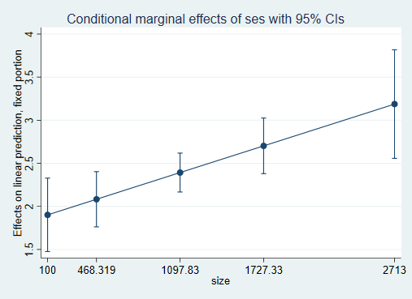

This shows the entire range of effect sizes for SES depending on size. We can see those as slopes if we calculate predicted values and plot them, but for that, let’s also save the minimum, maximum etc. for SES:

. sum ses

Variable | Obs Mean Std. dev. Min Max

-------------+---------------------------------------------------------

ses | 7,185 .0001434 .7793552 -3.758 2.692

. global sesmin=r(min)

. global sesmax=r(max)

. global sesmean=r(mean)

. global sesplussd=r(mean)+r(sd)

. global sesminussd=r(mean)-r(sd)

. margins, at(size=($sizemin $sizeminussd $sizemean $sizeplussd $sizemax) ses=($sesmin $sesminussd $sesmean $sesplussd $sesmax)) atmeans

Adjusted predictions Number of obs = 7,185

Expression: Linear prediction, fixed portion, predict()

1._at: ses = -3.758

size = 100

2._at: ses = -3.758

size = 468.3186

3._at: ses = -3.758

size = 1097.825

4._at: ses = -3.758

size = 1727.331

5._at: ses = -3.758

size = 2713

6._at: ses = -.7792118

size = 100

7._at: ses = -.7792118

size = 468.3186

8._at: ses = -.7792118

size = 1097.825

9._at: ses = -.7792118

size = 1727.331

10._at: ses = -.7792118

size = 2713

11._at: ses = .0001434

size = 100

12._at: ses = .0001434

size = 468.3186

13._at: ses = .0001434

size = 1097.825

14._at: ses = .0001434

size = 1727.331

15._at: ses = .0001434

size = 2713

16._at: ses = .7794985

size = 100

17._at: ses = .7794985

size = 468.3186

18._at: ses = .7794985

size = 1097.825

19._at: ses = .7794985

size = 1727.331

20._at: ses = .7794985

size = 2713

21._at: ses = 2.692

size = 100

22._at: ses = 2.692

size = 468.3186

23._at: ses = 2.692

size = 1097.825

24._at: ses = 2.692

size = 1727.331

25._at: ses = 2.692

size = 2713

------------------------------------------------------------------------------

| Delta-method

| Margin std. err. z P>|z| [95% conf. interval]

-------------+----------------------------------------------------------------

_at |

1 | 5.794493 .8937958 6.48 0.000 4.042685 7.5463

2 | 5.01541 .676854 7.41 0.000 3.6888 6.342019

3 | 3.683851 .4786823 7.70 0.000 2.745651 4.622051

4 | 2.352292 .6678443 3.52 0.000 1.043341 3.661243

5 | .2673639 1.296626 0.21 0.837 -2.273976 2.808704

6 | 11.45883 .395233 28.99 0.000 10.68418 12.23347

7 | 11.21964 .2993116 37.48 0.000 10.633 11.80628

8 | 10.81083 .2120376 50.99 0.000 10.39524 11.22642

9 | 10.40202 .2961318 35.13 0.000 9.821614 10.98243

10 | 9.761919 .5745359 16.99 0.000 8.63585 10.88799

11 | 12.94081 .3556007 36.39 0.000 12.24385 13.63778

12 | 12.84288 .2674408 48.02 0.000 12.31871 13.36705

13 | 12.6755 .1890731 67.04 0.000 12.30492 13.04607

14 | 12.50811 .2707095 46.20 0.000 11.97753 13.03869

15 | 12.24603 .5285042 23.17 0.000 11.21018 13.28188

16 | 14.4228 .3925439 36.74 0.000 13.65343 15.19217

17 | 14.46612 .2931934 49.34 0.000 13.89147 15.04077

18 | 14.54016 .2066463 70.36 0.000 14.13514 14.94518

19 | 14.6142 .3029515 48.24 0.000 14.02043 15.20798

20 | 14.73013 .5950645 24.75 0.000 13.56383 15.89644

21 | 18.05953 .6820231 26.48 0.000 16.72279 19.39627

22 | 18.44949 .5090456 36.24 0.000 17.45177 19.4472

23 | 19.11597 .3581556 53.37 0.000 18.414 19.81794

24 | 19.78245 .525949 37.61 0.000 18.75161 20.81329

25 | 20.82602 1.03428 20.14 0.000 18.79887 22.85317

------------------------------------------------------------------------------

. marginsplot, x(ses)

Variables that uniquely identify margins: size ses

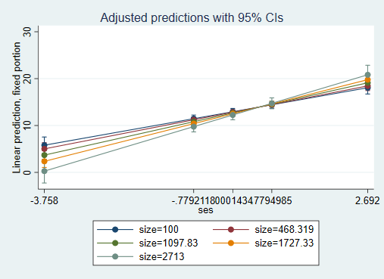

This is a bit too busy, let’s simplify to look at two extremes, minimum size and maximum size:

. margins, at(size=($sizemin $sizemax) ses=($sesmin $sesmean $sesmax)) atmeans

Adjusted predictions Number of obs = 7,185

Expression : Linear prediction, fixed portion, predict()

1._at : ses = -3.758

size = 100

2._at : ses = -3.758

size = 2713

3._at : ses = .0001434

size = 100

4._at : ses = .0001434

size = 2713

5._at : ses = 2.692

size = 100

6._at : ses = 2.692

size = 2713

------------------------------------------------------------------------------

| Delta-method

| Margin Std. Err. z P>|z| [95% Conf. Interval]

-------------+----------------------------------------------------------------

_at |

1 | 5.794493 .8937958 6.48 0.000 4.042685 7.5463

2 | .2673639 1.296626 0.21 0.837 -2.273976 2.808704

3 | 12.94081 .3556007 36.39 0.000 12.24385 13.63778

4 | 12.24603 .5285042 23.17 0.000 11.21018 13.28188

5 | 18.05953 .6820231 26.48 0.000 16.72279 19.39627

6 | 20.82602 1.03428 20.14 0.000 18.79887 22.85317

------------------------------------------------------------------------------

. marginsplot, x(ses) plotop(msymbol(i)) recastci(rarea) ciopts(fintensity(5))

scheme(s1mono)

Variables that uniquely identify margins: size ses



SIZE as the focal variable, SES as the moderator:

For a student with mean SES, when school size increases by 1 student, math achievement does not change – the main effect of school size is -.000266 but it’s not statistically significant. Let’s use margins to see what that effect of size looks like at other values of SES:

. margins, dydx(size) at(ses=($sesmin $sesminussd $sesmean $sesplussd $sesmax)) atmeans

Conditional marginal effects Number of obs = 7,185

Expression: Linear prediction, fixed portion, predict()

dy/dx wrt: size

1._at: ses = -3.758

size = 1056.862 (mean)

2._at: ses = -.7792118

size = 1056.862 (mean)

3._at: ses = .0001434

size = 1056.862 (mean)

4._at: ses = .7794985

size = 1056.862 (mean)

5._at: ses = 2.692

size = 1056.862 (mean)

------------------------------------------------------------------------------

| Delta-method

| dy/dx std. err. z P>|z| [95% conf. interval]

-------------+----------------------------------------------------------------

size |

_at |

1 | -.0021152 .0007501 -2.82 0.005 -.0035853 -.0006452

2 | -.0006494 .000332 -1.96 0.050 -.0013001 1.31e-06

3 | -.0002659 .0003041 -0.87 0.382 -.000862 .0003302

4 | .0001176 .0003413 0.34 0.730 -.0005514 .0007866

5 | .0010587 .0005935 1.78 0.074 -.0001046 .002222

------------------------------------------------------------------------------

Here we can see that the effect of school size is only significant for those with SES lower than 1 SD below the mean (the p value is exactly .05 for 1 SD below the mean, so we assume it will be significant anywhere below that). Let’s see that difference in effect sizes graphically:

. marginsplot

Variables that uniquely identify margins: ses

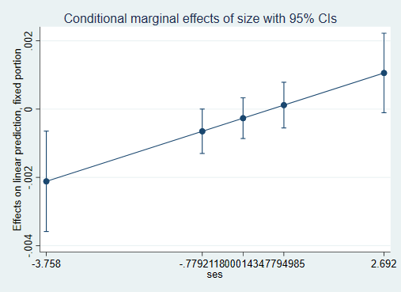

We can see which effects are statistically significant based on whether 0 is within the confidence interval or not. That might be better visible with a confidence band:

. marginsplot, x(ses) plotop(msymbol(i)) recastci(rarea) ciopts(fintensity(5))

> scheme(s1mono) xlabel(-3 -2 -1 0 1 2)

Variables that uniquely identify margins: ses



Finally, let’s see those effects of size as actual slopes:

. margins, at(size=($sizemin $sizeminussd $sizemean $sizeplussd $sizemax) ses=($sesmin $sesminussd $sesmean $sesplussd $sesmax)) atmeans

Adjusted predictions Number of obs = 7,185

Expression: Linear prediction, fixed portion, predict()

1._at: ses = -3.758

size = 100

2._at: ses = -3.758

size = 468.3186

3._at: ses = -3.758

size = 1097.825

4._at: ses = -3.758

size = 1727.331

5._at: ses = -3.758

size = 2713

6._at: ses = -.7792118

size = 100

7._at: ses = -.7792118

size = 468.3186

8._at: ses = -.7792118

size = 1097.825

9._at: ses = -.7792118

size = 1727.331

10._at: ses = -.7792118

size = 2713

11._at: ses = .0001434

size = 100

12._at: ses = .0001434

size = 468.3186

13._at: ses = .0001434

size = 1097.825

14._at: ses = .0001434

size = 1727.331

15._at: ses = .0001434

size = 2713

16._at: ses = .7794985

size = 100

17._at: ses = .7794985

size = 468.3186

18._at: ses = .7794985

size = 1097.825

19._at: ses = .7794985

size = 1727.331

20._at: ses = .7794985

size = 2713

21._at: ses = 2.692

size = 100

22._at: ses = 2.692

size = 468.3186

23._at: ses = 2.692

size = 1097.825

24._at: ses = 2.692

size = 1727.331

25._at: ses = 2.692

size = 2713

------------------------------------------------------------------------------

| Delta-method

| Margin std. err. z P>|z| [95% conf. interval]

-------------+----------------------------------------------------------------

_at |

1 | 5.794493 .8937958 6.48 0.000 4.042685 7.5463

2 | 5.01541 .676854 7.41 0.000 3.6888 6.342019

3 | 3.683851 .4786823 7.70 0.000 2.745651 4.622051

4 | 2.352292 .6678443 3.52 0.000 1.043341 3.661243

5 | .2673639 1.296626 0.21 0.837 -2.273976 2.808704

6 | 11.45883 .395233 28.99 0.000 10.68418 12.23347

7 | 11.21964 .2993116 37.48 0.000 10.633 11.80628

8 | 10.81083 .2120376 50.99 0.000 10.39524 11.22642

9 | 10.40202 .2961318 35.13 0.000 9.821614 10.98243

10 | 9.761919 .5745359 16.99 0.000 8.63585 10.88799

11 | 12.94081 .3556007 36.39 0.000 12.24385 13.63778

12 | 12.84288 .2674408 48.02 0.000 12.31871 13.36705

13 | 12.6755 .1890731 67.04 0.000 12.30492 13.04607

14 | 12.50811 .2707095 46.20 0.000 11.97753 13.03869

15 | 12.24603 .5285042 23.17 0.000 11.21018 13.28188

16 | 14.4228 .3925439 36.74 0.000 13.65343 15.19217

17 | 14.46612 .2931934 49.34 0.000 13.89147 15.04077

18 | 14.54016 .2066463 70.36 0.000 14.13514 14.94518

19 | 14.6142 .3029515 48.24 0.000 14.02043 15.20798

20 | 14.73013 .5950645 24.75 0.000 13.56383 15.89644

21 | 18.05953 .6820231 26.48 0.000 16.72279 19.39627

22 | 18.44949 .5090456 36.24 0.000 17.45177 19.4472

23 | 19.11597 .3581556 53.37 0.000 18.414 19.81794

24 | 19.78245 .525949 37.61 0.000 18.75161 20.81329

25 | 20.82602 1.03428 20.14 0.000 18.79887 22.85317

------------------------------------------------------------------------------

. marginsplot, x(size)

Variables that uniquely identify margins: size ses

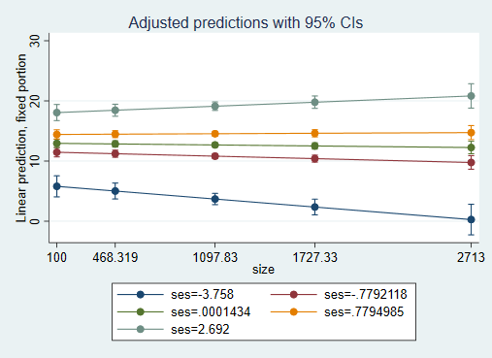

. marginsplot, x(size) plotop(msymbol(i)) recastci(rarea) ciopts(fintensity(5)) scheme(s1mono)

Variables that uniquely identify margins: size ses

